# Full Stack Development with MERN — Project Documentation
- Introduction
Project Title: SHOPEZ — E-Commerce Management System
- Project Overview
Purpose
SHOPEZ is a web-based house product management platform built using the MERN stack. It connects **product admins**, **customers**, and **admins** in one system. Admins list product properties; customers browse listings and schedule order appointments; admins monitor users, properties, and order requests across the platform.
Features
- User registration & login with role-based access (Admin, Admin, Customer)
- Product management — admins can add, view, update, and delete product listings with images
- Product browsing — customers and public users can search and filter properties by title, address, and city
- Visit appointment booking — customers schedule a date and time to order a product
- Price negotiation — customers can propose a lower rent; admins accept or reject the offer
- Visit request management — admins approve/reject order requests; admins can oversee all requests
- Role-based dashboards — separate dashboards for Admin, Admin, and Customer
- Image upload — product photos stored on the server via Multer
3. Architecture
Frontend
The frontend is a **React 18** single-page application (SPA) built with **Vite**.
| Component | Technology |
|-----------|-----------|
| UI Framework | React 18 |
| Build Tool | Vite 5 |
| Routing | React Router v6 |
| HTTP Client | Axios |
| Styling | Custom CSS (`App.css`, `index.css`) |
| State Management | React `useState` / `useEffect` (no Redux) |
Structure:
- `App.jsx` — central route definitions
- `modules/common/` — public pages (Home, Login, Register)
- `modules/admin/` — admin dashboard pages
- `modules/user/admin/` — admin dashboard pages
- `modules/user/customer/` — customer dashboard pages
- `components/` — reusable UI (Navbar, ProductCard, modals)
- `utils/` — API helpers and formatters
Role-based routing is enforced by the `ProtectedRoute` component, which checks `localStorage` for the logged-in user and their role.
Backend
The backend is a Node.js REST API using Express.js 5.
| Layer | Location | Responsibility |
|-------|----------|----------------|
| Entry Point | `server.js` | App setup, middleware, route mounting |
| Routes | `routes/` | Endpoint definitions |
| Controllers | `controllers/` | Business logic and validation |
| Models | `models/` | Mongoose schemas |
| Uploads | `uploads/upload.js` | Multer configuration for images |
API base URL: http://localhost:8000
Route prefixes:
- /api/users — customer & auth endpoints
- /api/admins — admin product & booking endpoints
- /api/admin — admin management endpoints
- /uploads — static product images
Database
MongoDB is used with **Mongoose ODM**. Database name: `shopezdb`
Collections & Schema
Users Collection javascript
{
name: String (required), email: String (required, unique), password: String (required, hashed), role: String (enum: "admin" | "admin" | "user", default: "user"), phone: String, timestamps: true
}
Properties Collection javascript
{ title: String (required), address: String (required), city: String (required), admin: ObjectId → User (required), productType: String (enum: "House" | "Apartment" | "Villa"), price: Number (required), description: String, image: String (file path), timestamps: true
}
Orders Collection javascript
{
user: ObjectId → User (required), product: ObjectId → Product (required), orderDate: Date (required), orderTime: String (required), status: String (enum: "Pending" | "Approved" | "Rejected"), listedPrice: Number, proposedPrice: Number, agreedPrice: Number, negotiationStatus: String (enum: "None" | "Pending" | "Accepted" | "Rejected"), timestamps: true
}
Entity Relationships
User (admin) ──1:N──▶ Product
User (customer) ──1:N──▶ Order ◀──N:1── Product
- Setup Instructions
Prerequisites
| Software | Version |
|----------|---------|
| Node.js | v18 or higher |
| MongoDB | v6 or higher (local or Atlas) |
| npm | v9 or higher |
| Git | Latest |
Installation
- Folder Structure
Client
Client/
├── index.html
├── package.json
├── vite.config.js
└── src/
├── main.jsx | # React entry point
├── App.jsx | # Route definitions
├── App.css | # Global styles
├── index.css | # CSS variables & base styles
├── components/
│ ├── Navbar.jsx # Public navigation bar
│ ├── DashboardNav.jsx # Dashboard sidebar navigation
│ ├── ProtectedRoute.jsx # Role-based route guard
│ ├── ProductCard.jsx # Product listing card
│ ├── ProductDetailsModal.jsx
│ ├── BookProductModal.jsx # Visit appointment form
│ └── CustomerProfileModal.jsx
├── modules/
│ ├── common/
│ │ ├── Home.jsx  │ │ ├── Login.jsx | # Public landing page
│ │ ├── register.jsx
│ │ └── ForgotPassword.jsx
│ ├── admin/
│ │ ├── AdminHome.jsx
│ │ ├── AllUsers.jsx
│ │ ├── AllProduct.jsx
│ │ └── AllOrders.jsx
│ └── user/
│ ├── admin/
│ | │ ├── AdminHome.jsx
│ | │ ├── AddProduct.jsx
│ | │ ├── AllProperties.jsx
│ | │ └── AllOrders.jsx
│ └── customer/
│ ├── CustomerHome.jsx
│ ├── AllProperties.jsx
│ └── CustomerOrders.jsx
└── utils/
├── api.js # API URL & localStorage helpers
└── formatVisit.js # Visit date/time formatters
Server
Server/
├── server.js # Express app entry point
├── package.json
├── .env # Environment variables
├── config/
│ └── connect.js # MongoDB connection
├── models/
│ ├── UserSchema.js
│ ├── ProductSchema.js
│ └── OrderSchema.js
├── controllers/
│ ├── userController.js | # Auth, browse, book order
│ ├── adminController.js | # Product CRUD, order management
│ └── adminController.js | # Platform-wide management
├── routes/
│ ├── userRoutes.js
│ ├── adminRoutes.js
│ └── adminRoutes.js
├── uploads/
│ ├── upload.js # Multer configuration
│ └── [product images]
└── scripts/
└── removeSaleProperties.js # Database cleanup utility
- Running the Application
Terminal 1 — Start Backend bash cd Server npm start
Server runs at: http://localhost:8000
Terminal 2 — Start Frontend bash cd Client
npm run dev
Frontend runs at: http://localhost:5173
- API Documentation
Base URL:http://localhost:8000
User / Auth Routes — /api/users
POST /api/users/signup Register a new user.
Request Body:
json
{
"name": "John Doe",
"email": "john@example.com",
"password": "password123",
"phone": "9876543210",
"role": "user"
}
Response (201):
json
{
"_id": "...",
"name": "John Doe",
"email": "john@example.com",
"phone": "9876543210",
"role": "user"
}
POST /api/users/login Authenticate a user.
Request Body: json
{
"email": "john@example.com",
"password": "password123"
}
Response (200):
json
{
"_id": "...",
"name": "John Doe",
"email": "john@example.com",
"role": "user",
"phone": "9876543210"
}
POST /api/users/forgot-password
Request password reset (stub implementation).
Request Body:
json
{ "email": "john@example.com" }
Response (200):
json
{
"message": "If an account exists, password reset instructions have been sent to your email."
}
GET /api/users/properties Browse all product properties.
Response (200):
json
[
{
"_id": "...",
"title": "2BHK Apartment",
"address": "123 Main Street",
"city": "Mumbai",
"price": 25000,
"productType": "Apartment",
"description": "Spacious 2BHK...",
"image": "uploads/1234567890-photo.jpg",
"admin": { "name": "Admin Name", "email": "admin@example.com" }
}
]
POST /api/users/book-product Schedule a product order appointment.
Request Body:
json
{
"user": "userId",
"product": "productId", "orderDate": "2026-06-20",
"orderTime": "14:30",
"proposedPrice": 22000
}
```
Response (201):
json
{
"_id": "...",
"user": { "name": "John Doe", "email": "john@example.com" }, "product": { "title": "2BHK Apartment", "city": "Mumbai", "price": 25000 },
"orderDate": "2026-06-20T00:00:00.000Z",
"orderTime": "14:30",
"status": "Pending",
"listedPrice": 25000,
"proposedPrice": 22000,
"negotiationStatus": "Pending"
}
GET /api/users/my-orders?userId=<id> Get all order requests for a customer.
Query Parameters: userId(required)
Response (200): Array of booking objects with populated product details.
Admin Routes — /api/admins
POST /api/admins/product
Add a new product product (multipart/form-data).
Form Fields:
| Field | Type | Required |
|-------|------|----------|
| title | string | Yes |
| address | string | Yes |
| city | string | Yes |
| price | number | Yes |
| productType | string | Yes |
| description | string | No |
| admin | string (userId) | Yes |
| image | file | No |
Response (201): Created product object.
GET /api/admins/properties?adminId=<id> Get properties listed by an admin.
Query Parameters:adminId (optional)
PUT /api/admins/product/:id
Update a product.
Request Body: Any updatable product fields.
DELETE /api/admins/product/:id Delete a product.
Response (200):
json
{ "message": "Product deleted successfully" }
GET /api/admins/orders?adminId=<id>
Get order requests for an admin's properties.
Query Parameters:adminId (required)
PUT /api/admins/booking/:id
Approve or reject a order request.
Request Body
json
{
"adminId": "adminId",
"status": "Approved"
}
PUT /api/admins/booking/:id/negotiation Accept or reject a price negotiation offer.
Request Body:
json
{
"adminId": "adminId",
"action": "Accept"
}
Admin Routes — /api/admin
GET /api/admin/users
List all registered users (password excluded).
GET /api/admin/properties
List all properties with admin details.
GET /api/admin/orders
List all order requests across the platform.
PUT /api/admin/booking/:id
Update any order request status.
Request Body:
json
{ "status": "Approved" }
8. Authentication
Authentication Method
The project uses client-side session storage with bcrypt password hashing. JWT tokens are not used.
Registration Flow
- User submits the registration form with name, email, password, phone, and role.
- Backend checks if the email already exists.
- Password is hashed using bcryptjs(salt rounds: 10).
- User document is saved to MongoDB.
- User object (without password) is returned to the client.
Login Flow
- User submits email and password.
- Backend finds the user by email.
- Password is verified with bcrypt.compare().
- On success, the user object is stored in localStorage: javascript localStorage.setItem("user", JSON.stringify(userData));
- User is redirected based on role:
- admin → /admin
- admin` → /admin
- user (customer) → /customer
Authorization
Role-based access is enforced on the **frontend** via the ProtectedRoute component:
javascript
<ProtectedRoute allowedRoles={["admin"]}>
<AdminHome />
</ProtectedRoute>
| Role | Access |
|------|--------|
| `admin` | Admin dashboard, all users/properties/orders |
| `admin` | Admin dashboard, own properties & order requests |
| `user` | Customer dashboard, browse properties, schedule orders |
9. User Interface
Public Pages
| Page | Route | Description |
|------|-------|-------------|
| Home | `/` | Landing page with product search, sort, and browse |
| Login | `/login` | User authentication |
| Register | `/register` | New user registration |
| Forgot Password | `/forgot-password` | Password recovery form |
| Browse Properties | `/properties` | Public product listing |
Admin Dashboard
| Page | Route | Description |
|------|-------|-------------|
| Dashboard | `/admin` | Platform statistics (users, properties, order requests) |
| All Users | `/admin/users` | View all registered users |
| All Properties | `/admin/properties` | View all listed properties |
| Visit Requests | `/admin/orders` | Manage all order appointments |
Admin Dashboard
| Page | Route | Description |
|------|-------|-------------|
| Dashboard | `/admin` | Product and order request counts |
| Add Product | `/admin/add-product` | Form to list a new product product |
| My Properties | `/admin/properties` | View and delete own listings |
| Visit Requests | `/admin/orders` | Review, approve/reject orders and price offers |
Customer Dashboard
| Page | Route | Description |
|------|-------|-------------|
| Dashboard | `/customer` | Available properties and order count stats |
| Browse | `/customer/properties` | Search and schedule product orders |
| My Visits | `/customer/orders` | Track order appointment status |
Key UI Components
-ProductCard — displays product image, title, location, price, and type badge
- BookProductModal— order date/time picker with optional price negotiation
- ProductDetailsModa — full product details with Schedule Visit button
- CustomerProfileModal — customer contact info and order details for admins
10. Testing
Current Status
Automated testing is not yet implemented in this project. The package.json test script is a placeholder.
Recommended Testing Strategy
| Type | Tool | Scope |
|------|------|-------|
| Unit Tests | Jest | Controllers, utility functions |
| API Tests | Supertest + Jest | All REST endpoints |
| Component Tests | React Testing Library | Forms, modals, route guards |
| E2E Tests | Cypress or Playwright | Full user flows (login → book order) |
Manual Testing Checklist
- [ ] Register as Admin, Customer, and Admin
- [ ] Login with correct and incorrect credentials
- [ ] Admin adds product with and without image
- [ ] Customer browses and searches properties
- [ ] Customer schedules order with and without price negotiation
- [ ] Admin approves/rejects order requests
- [ ] Admin accepts/rejects price offers
- [ ] Admin views all users, properties, and orders
- [ ] Role-based route protection (wrong role redirected)
- Screenshots or Demo

- Known Issues
| # | Issue | Severity | Description |
|---|-------|----------|-------------|
| 1 | No server-side auth middleware | High | API endpoints do not verify JWT/session; user IDs are passed from the client and can be spoofed |
| 2 | Forgot password is a stub | Medium | Password reset endpoint returns a success message but does not send email |
| 3 | No input sanitization | Medium | User inputs are not sanitized against XSS or injection |
| 4 | No order slot conflict check | Low | Multiple customers can book the same date/time for the same product |
| 5 | No email notifications | Low | Admins/customers are not notified when order status changes |
| 6 | Images stored locally | Low | Uploaded images are stored on the server filesystem; not suitable for cloud deployment without changes |
| 7 | Legacy plain-text passwords | Low | Login supports legacy unhashed passwords for backward compatibility |
13. Future Enhancements
| Feature | Description |
|---------|-------------|
| JWT Authentication | Secure API with token-based auth and refresh tokens |
| Email Notifications | Notify admins and customers on order status changes |
| Real-time Chat | In-app messaging between customer and admin |
| Visit Slot Management | Prevent double-booking of the same time slot |
| Product Reviews & Ratings | Customer feedback after product orders |
| Advanced Search Filters | Filter by price range, product type, city, amenities |
| Payment Integration | Online rent payment via Razorpay/Stripe |
| Google Maps Integration | Show product location on an interactive map |
| Admin Analytics Dashboard | Charts for orders, revenue, and user growth |
| Cloud Image Storage | Migrate uploads to AWS S3 or Cloudinary |
| Mobile Responsive PWA | Progressive Web App for mobile users |
| Automated Testing | Jest + Supertest + Cypress test suite |
SHOPEZ E-Commerce Project Screenshots
Home Page
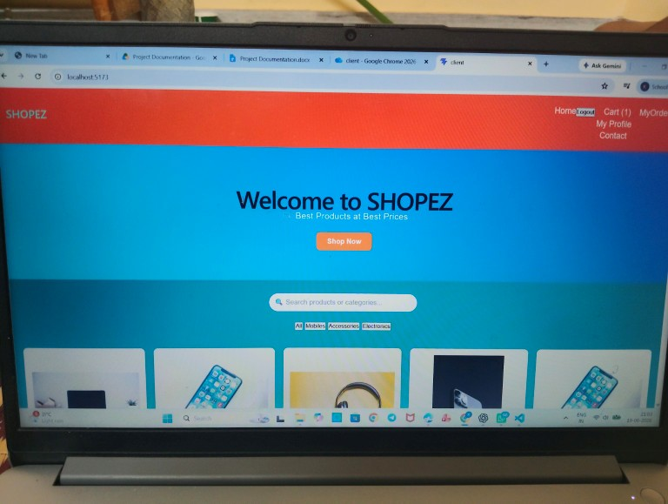
Product Listing
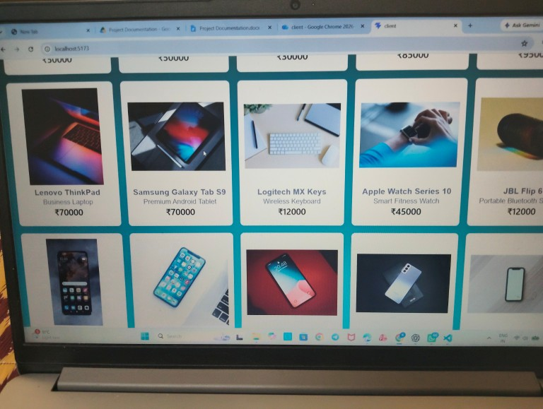
Product Details
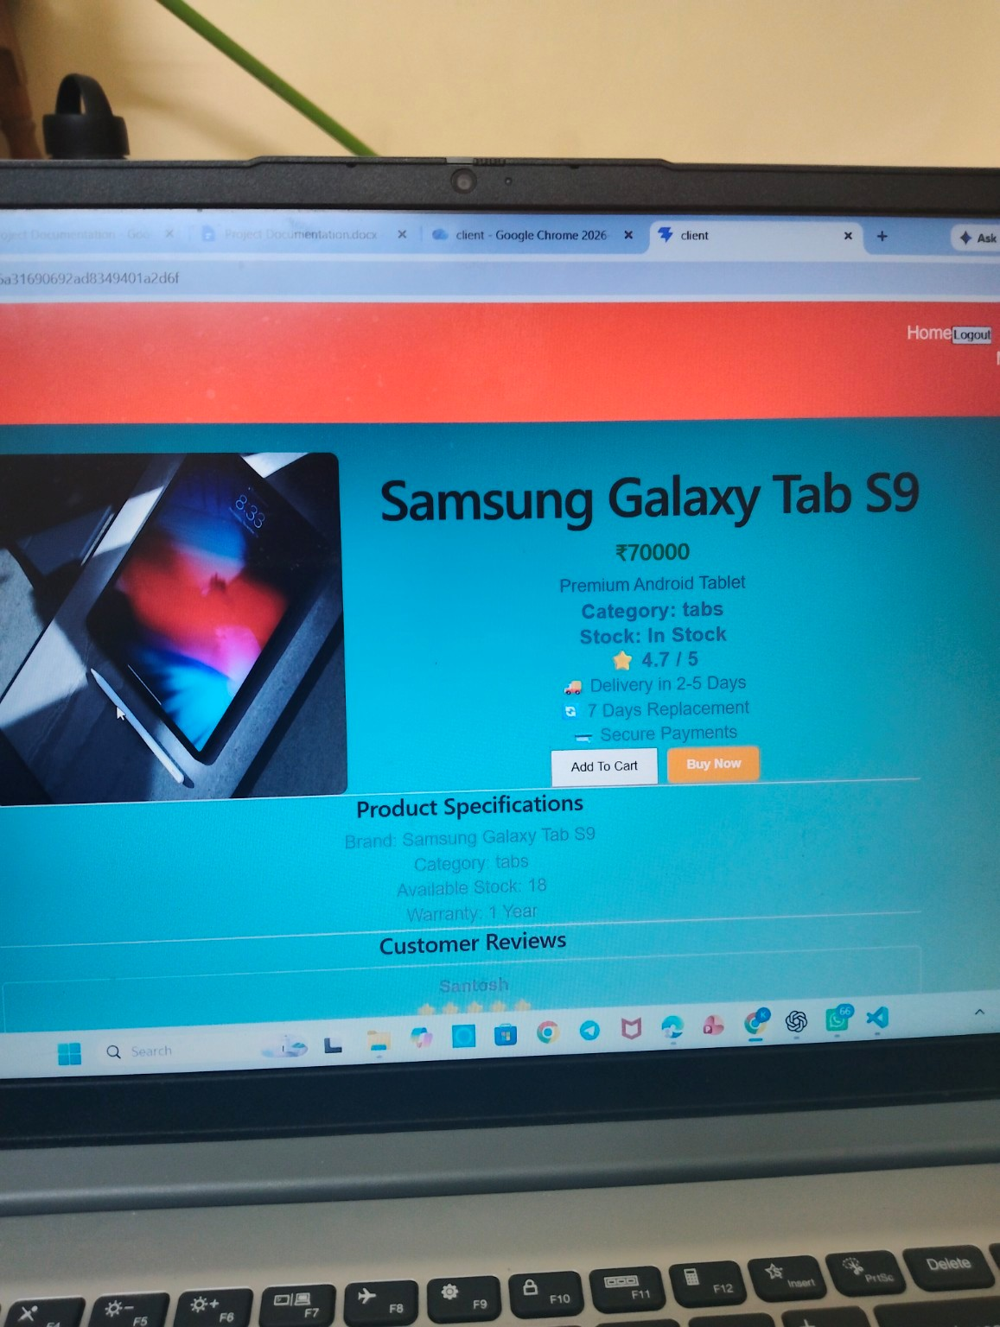
Customer Reviews
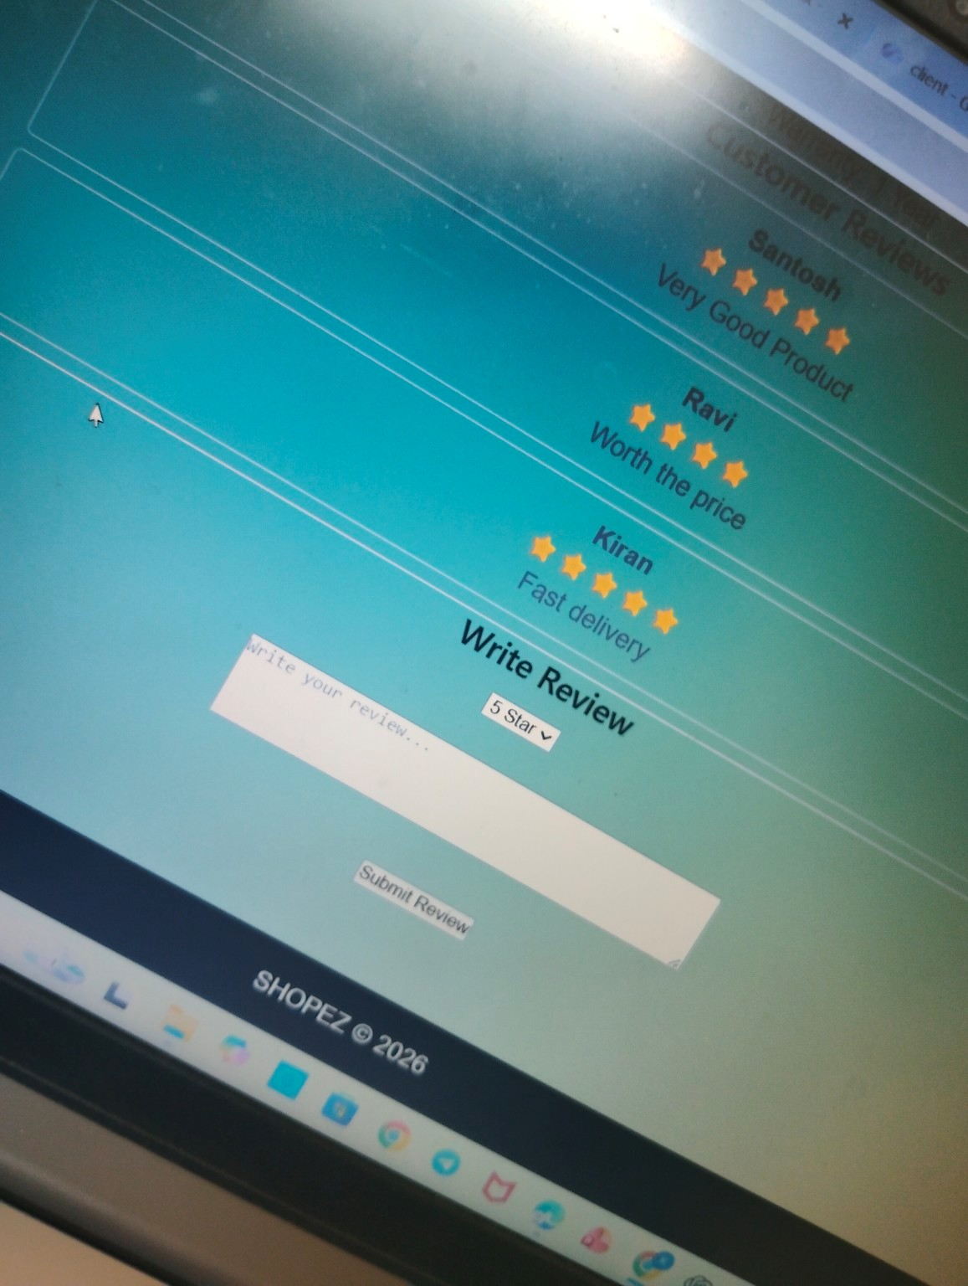
User Profile
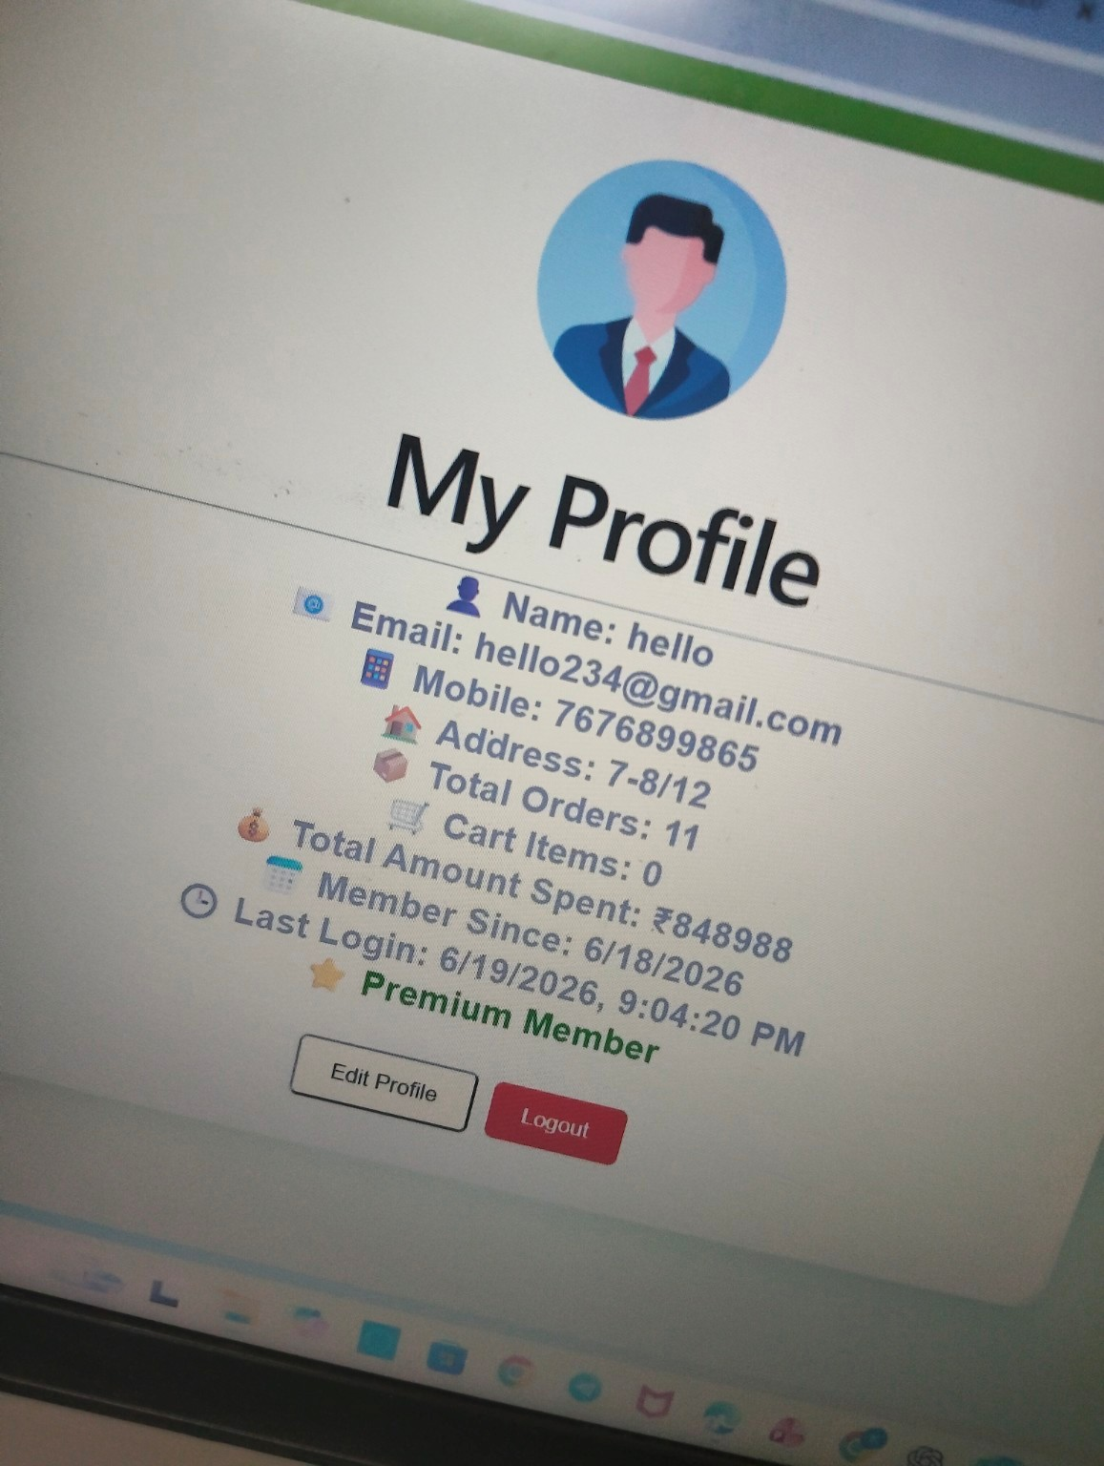
My Orders
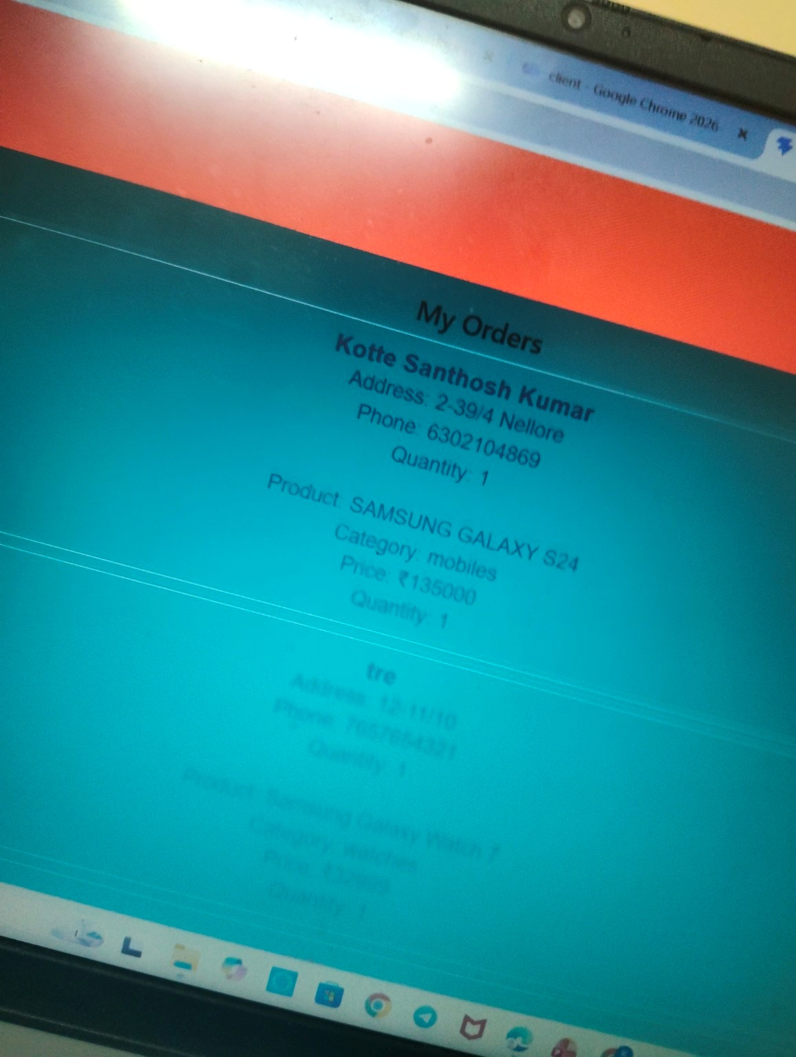
Contact Page
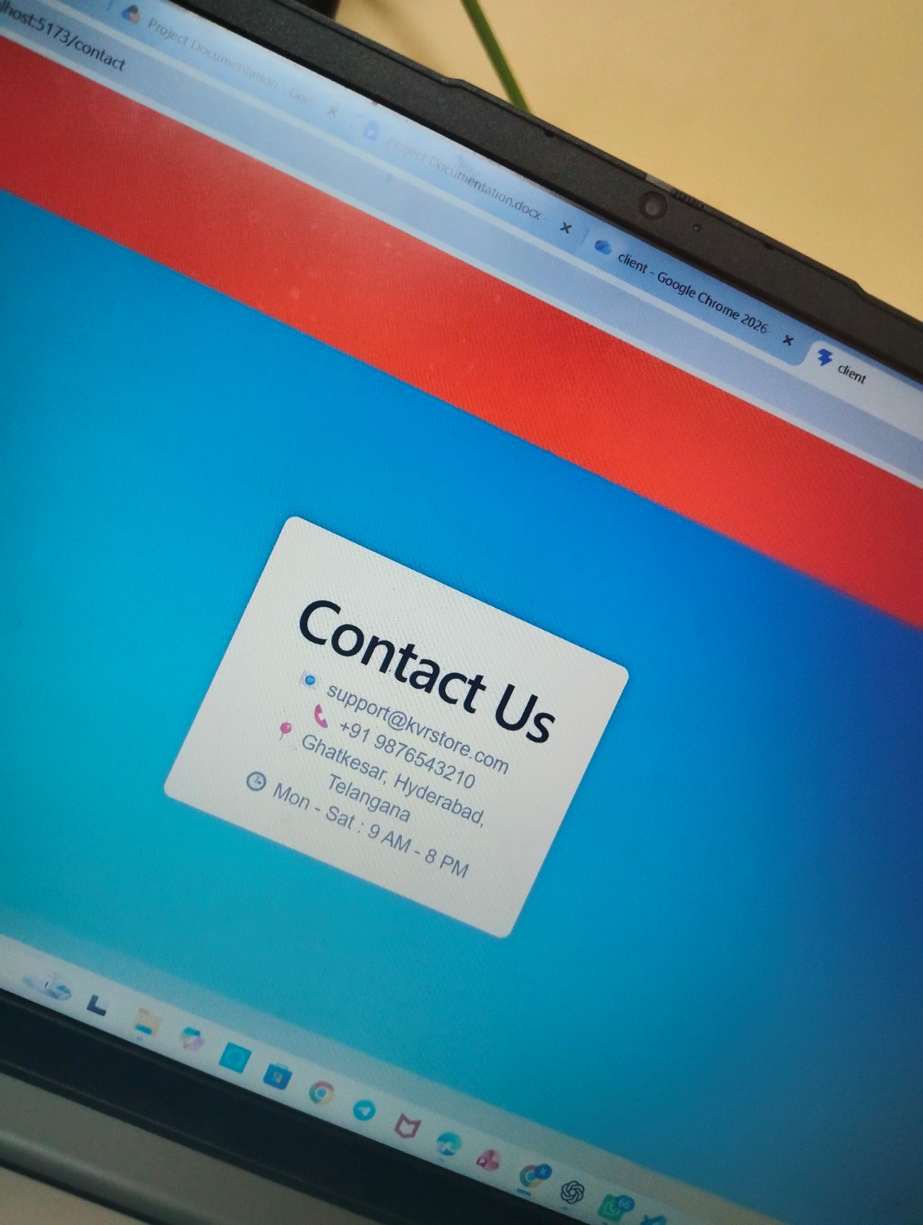
Login Page
